**One way analysis of variance (ANOVA)**

For testing homoscedasticity of the variance across various levels, Levene Statistic has been used. Levene test is used to assess whether the variance of a single metric variable are equal across any number of groups (Hair et al., 2019, p.98). Result indicated that non-rejection of null hypotheses at p>0.05 level (see table 7). **Therefore, the variance of the variables is homogenous and assumption for ANOVA has been confirmed.**

|  |  |  |  |  |  |
| --- | --- | --- | --- | --- | --- |
| **Table 7. Tests of Homogeneity of Variances** | | | | | |
|  | | Levene Statistic | df1 | df2 | Sig. |
| writing score | Based on Mean | 1.726 | 2 | 197 | .181 |
| Based on Median | 1.689 | 2 | 197 | .187 |
| Based on Median and with adjusted df | 1.689 | 2 | 196.003 | .187 |
| Based on trimmed mean | 1.821 | 2 | 197 | .165 |

A one -way between-groups analysis of variance (ANOVA) was used to compare the mean writing score among the different programs(general , vocational and academic). The difference was statistically significance at p<0.05 in different programs: F= 21.275, p = 0.001. Therefore the null hypothesis that there is no difference in programs, the population is rejected. It can be concluded that there is signifance difference in programs in the population. The result also indicates that mean groups for academic(M=56.26, SD=7.94) was the highest among the other.

|  |  |  |  |  |  |
| --- | --- | --- | --- | --- | --- |
| **Table 8. ANOVA RESULT** | | | | | |
| writing score | | | | | |
|  | Sum of Squares | df | Mean Square | F | Sig. |
| Between Groups | 3175.698 | 2 | 1587.849 | 21.275 | .000 |
| Within Groups | 14703.177 | 197 | 74.635 |  |  |
| Total | 17878.875 | 199 |  |  |  |

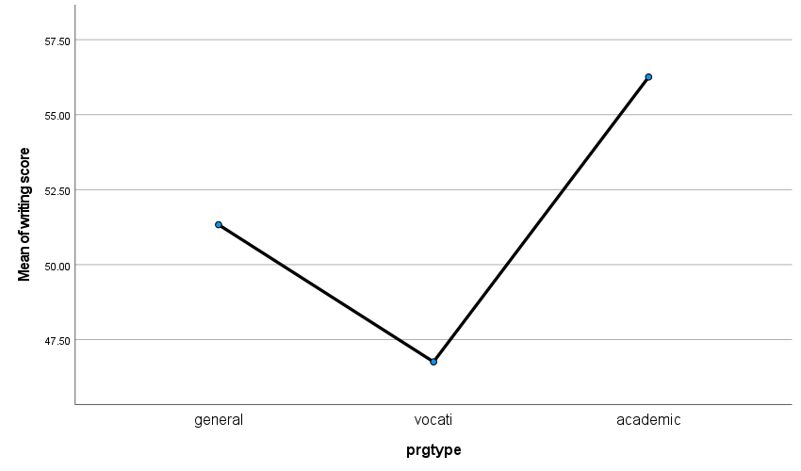

Post hoc test

As the group difference was significant, the post hoc test was run using Tukey HSD. All group difference were significant at p<0.05.

|  |  |  |  |  |  |  |
| --- | --- | --- | --- | --- | --- | --- |
| **Multiple Comparisons** | | | | | | |
| Dependent Variable: writing score | | | | | | |
| Tukey HSD | | | | | | |
| (I) prgtype | (J) prgtype | Mean Difference (I-J) | Std. Error | Sig. | 95% Confidence Interval | |
| Lower Bound | Upper Bound |
| general | vocati | 4.57333* | 1.77518 | .029 | .3811 | 8.7655 |
| academic | -4.92381* | 1.53928 | .005 | -8.5589 | -1.2887 |
| vocati | general | -4.57333* | 1.77518 | .029 | -8.7655 | -.3811 |
| academic | -9.49714* | 1.48443 | .000 | -13.0027 | -5.9916 |
| academic | general | 4.92381* | 1.53928 | .005 | 1.2887 | 8.5589 |
| vocati | 9.49714* | 1.48443 | .000 | 5.9916 | 13.0027 |
| *. The mean difference is significant at the 0.05 level. | | | | | | |